King James VI and Jamestown

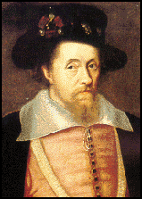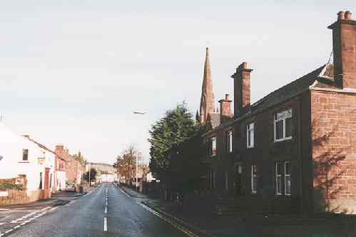

It has often been said, and it is probably true, that the village of Jamestown – originally known as “Damheid” from the Carrochan Burn Dam and the Mill of Balloch – took its name from the fact that, around 1790, several of the proprietors of its few properties had the Christian name of James. However, the fact remains that the hamlet had a considerably older association with King James VI of Scots.

King James had a life-long passion for hunting deer. As a young man, in the years before 1603, it was his habit to come over from Stirling or Edinburgh in the month of August. From his royal castle at Dumbarton he would travel northwards to Inchmurrin, the island on Loch Lomond, to chase the deer to his heart’s content.

Clearly King James and his courtiers must have passed through the Vale of Leven on many occasions on their way from Dumbarton Castle to Inchmurrin and back. The royal party was probably mounted, being ferried to Inchmurrin from Balloch. Given that the King’s cavalcade was likely to have journeyed by the eastern bank of the Leven (at that time there were no bridges across the river and there would have been no point in splashing through the Leven unnecessarily), they must frequently have passed through the old village of Bonhill (first mentioned in 1270). It is, indeed, by no means impossible that this king, so concerned with religion, may have visited the little parish kirk there.

The party would have proceeded northward to Damheid by Dalvait (recorded as early as the 16th century). Dalvait – meaning “the field of the boats” – was a small community of salmon fishers.

In the year 1617 King James Sixth of Scots and, by then, First of Great Britain came up from London to visit his original realm of Scotland. In the month of July he travelled through the Vale of Leven, once more on his way northwards to hunt deer on Inchmurrin. James with his courtiers would have ridden along the track where the present Main Street of Bonhill now runs, continued northwards approximately by our A813 “Jamestown Road”, through Damheid, down by Dalvait, on to the Ferry of Balloch and thence to Inchmurrin.

This extraordinary man who founded the United Kingdom, initiated the British Empire and gave the world the Authorised Version of the Bible, must have ridden over the very ground within yards of which Jamestown Kirk would one day come to be built.

W. Scobie



